**马力和千瓦的转换表**

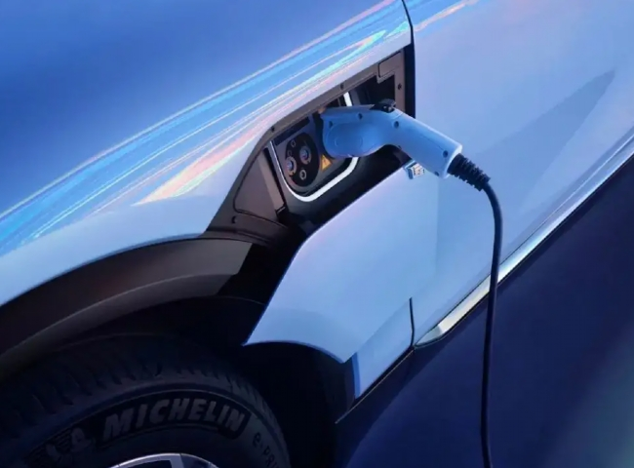

|  |  |  |  |  |  |  |  |  |  |
| --- | --- | --- | --- | --- | --- | --- | --- | --- | --- |
| 马力与千瓦换算表 |  |  |  |  |  |  |  |  |  |
| 马- | 公斤- | 马- | 公斤- | 马- | 公斤- | 马- | 公斤- | 马- | 公斤- |
| 力量 | 瓦 | 力量 | 瓦 | 力量 | 瓦 | 力量 | 瓦 | 力量 | 瓦 |
| 1 | 0.7457 | 34 | 25.3538 | 67 | 49.9619 | 100 | 74.57 | 133 | 99.1781 |
| 2 | 1.4914 | 35 | 26.0995 | 68 | 50.7076 | 101 | 75.3157 | 134 | 99.9238 |
| 3 | 2.2371 | 36 | 26.8452 | 69 | 51.4533 | 102 | 76.0614 | 135 | 100.6695 |
| 4 | 2.9828 | 37 | 27.5909 | 70 | 52.199 | 103 | 76.8071 | 136 | 101.4152 |
| 5 | 3.7285 | 38 | 28.3366 | 71 | 52.9447 | 104 | 77.5528 | 137 | 102.1609 |
| 6 | 4.4742 | 39 | 29.0823 | 72 | 53.6904 | 105 | 78.2985 | 138 | 102.9066 |
| 7 | 5.2199 | 40 | 29.828 | 73 | 54.4361 | 106 | 79.0442 | 139 | 103.6523 |
| 8 | 5.9656 | 41 | 30.5737 | 74 | 55.1818 | 107 | 79.7899 | 140 | 104.398 |
| 9 | 6.7113 | 42 | 31.3194 | 75 | 55.9275 | 108 | 80.5356 | 141 | 105.1437 |
| 10 | 7.457 | 43 | 32.0651 | 76 | 56.6732 | 109 | 81.2813 | 142 | 105.8894 |
| 11 | 8.2027 | 44 | 32.8108 | 77 | 57.4189 | 110 | 82.027 | 143 | 106.6351 |
| 12 | 8.9484 | 45 | 33.5565 | 78 | 58.1646 | 111 | 82.7727 | 144 | 107.3808 |
| 13 | 9.6941 | 46 | 34.3022 | 79 | 58.9103 | 112 | 83.5184 | 145 | 108.1265 |
| 14 | 10.4398 | 47 | 35.0479 | 80 | 59.656 | 113 | 84.2641 | 146 | 108.8722 |
| 15 | 11.1855 | 48 | 35.7936 | 81 | 60.4017 | 114 | 85.0098 | 147 | 109.6179 |
| 16 | 11.9312 | 49 | 36.5393 | 82 | 61.1474 | 115 | 85.7555 | 148 | 110.3636 |
| 17 | 12.6769 | 50 | 37.285 | 83 | 61.8931 | 116 | 86.5012 | 149 | 111.1093 |
| 18 | 13.4226 | 51 | 38.0307 | 84 | 62.6388 | 117 | 87.2469 | 150 | 111.855 |
| 19 | 14.1683 | 52 | 38.7764 | 85 | 63.3845 | 118 | 87.9926 | 151 | 112.6007 |
| 20 | 14.914 | 53 | 39.5221 | 86 | 64.1302 | 119 | 88.7383 | 152 | 113.3464 |
| 21 | 15.6597 | 54 | 40.2678 | 87 | 64.8759 | 120 | 89.484 | 153 | 114.0921 |
| 22 | 16.4054 | 55 | 41.0135 | 88 | 65.6216 | 121 | 90.2297 | 154 | 114.8378 |
| 23 | 17.1511 | 56 | 41.7592 | 89 | 66.3673 | 122 | 90.9754 | 155 | 115.5835 |
| 24 | 17.8968 | 57 | 42.5049 | 90 | 67.113 | 123 | 91.7211 | 156 | 116.3292 |
| 25 | 18.6425 | 58 | 43.2506 | 91 | 67.8587 | 124 | 92.4668 | 157 | 117.0749 |
| 26 | 19.3882 | 59 | 43.9963 | 92 | 68.6044 | 125 | 93.2125 | 158 | 117.8206 |
| 27 | 20.1339 | 60 | 44.742 | 93 | 69.3501 | 126 | 93.9582 | 159 | 118.5663 |
| 28 | 20.8796 | 61 | 45.4877 | 94 | 70.0958 | 127 | 94.7039 | 160 | 119.312 |
| 29 | 21.6253 | 62 | 46.2334 | 95 | 70.8415 | 128 | 95.4496 | 161 | 120.0577 |
| 30 | 22.371 | 63 | 46.9791 | 96 | 71.5872 | 129 | 96.1953 | 162 | 120.8034 |
| 31 | 23.1167 | 64 | 47.7248 | 97 | 72.3329 | 130 | 96.941 | 163 | 121.5491 |
| 32 | 23.8624 | 65 | 48.4705 | 98 | 73.0786 | 131 | 97.6867 | 164 | 122.2948 |
| 33 | 24.6081 | 66 | 49.2162 | 99 | 73.8243 | 132 | 98.4324 | 165 | 123.0405 |